GAME DVD ORDER FORM
ICE HOCKEY – 2014 SILVER STICK PACIFIC DISTRICT REGIONAL (NOV 26-30, 2014)
TEAM: DIVISION:
DESCRIPTION
Individual Copies or Box Sets of Un-Edited Game DVDs with Live Commentary & Scoreboard Graphics

GROUP DISCOUNTS
We provide group discounts for multiple orders from the same team placed at the same time.
SPECIAL PRE-ORDER OFFER (placed before 5PM on 11/26/14): 5+ GOLD Packages = $50.00 EACH (33% OFF)
ON-SITE/POST-EVENT: 3 Packages = 10% discount, 5 Packages = 15% discount, 7+ packages = 20% discount

PACKAGES
COPPER: 1 MITE SESSION or 1 GAME (other divisions) $ 30.00
BRONZE: 2 MITE SESSIONS $ 50.00
SILVER: 3 MITE SESSIONS $ 65.00
GOLD: 4 MITE SESSIONS $ 75.00
PLATINUM: 5 MITE SESSIONS (includes Consolation or Championship) $ 85.00

ADDITIONAL PACKAGES (# ): $
SHIPPING*: $
DISCOUNT:
TOTAL: $
SELECTED SESSIONS
Please email us at INFO@BLACKDOGENTERPRISES.ORG with any questions.
Mites: All games will be covered. All other divisions: only Championship Games will be covered.
Each Mite “Session” includes 2 games (e.g., Session #1 includes Games #1-2). No substitutions.

SESSION/GM #1: , SESSION #2: , SESSION #3: , SESSION #4: , SESSION #5:

PAYMENT/SHIPPING INFO
CASH ($ ) CHECK (# ) CREDIT or DEBIT CARD 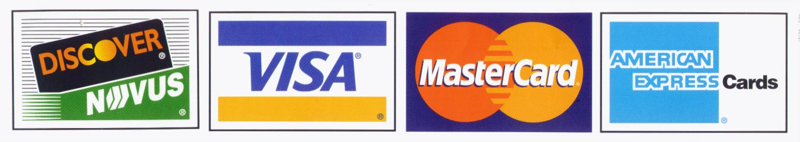
CREDIT/DEBIT CARD # EXP CVV
NAME
SHIPPING/BILLING ADDRESS
CITY STATE ZIP
PHONE ( ) EMAIL

Please make checks payable to: BLACK DOG ENTERPRISES
Note: A $25 returned check service charge is assessed for each dishonored check the bank returns.
All orders will be completed and mailed to your address within 3 weeks of the end of Tournament.
*Shipping is FREE, except for Group (3+) or International orders: PLEASE ADD $5.00 SHIPPING PER PACKAGE.

