HIGHLIGHT REEL ORDER FORM
ICE HOCKEY – 2014 MLK GIRLS/WOMEN’S TOURNAMENT (JAN 17-20, 2014)
TEAM: enter your team's name DIVISION: enter your team's division
PLAYER #: ## PLAYER NAME: enter player's name POSITION(S): enter player's position(s)
DESCRIPTION
Dynamic Edited DVDs that showcase an individual player’s or an entire team’s best hits, goals, and saves from the tournament. Each reel includes game footage with live audio commentary, music, graphics, and a player/team profile. Each package includes one personalized DVD and posting of footage on our website and YouTube channel.

GROUP DISCOUNTS
We provide group discounts for multiple orders from the same team placed at the same time.
EXTRA PACKAGE DISCOUNT: 10% off per additional package ordered up to 50% off for all packages.

PACKAGES
CAMEO: HIGHLIGHT REEL w/CLIPS FROM 1-2 GAMES $ 250.00
PLAYMAKER: HIGHLIGHT REEL w/CLIPS FROM 3 GAMES $ 350.00
GOAL-SCORER: HIGHLIGHT REEL w/CLIPS FROM 4 GAMES $ 400.00
ALL-STAR: HIGHLIGHT REEL w/CLIPS FROM 5 GAMES $ 450.00

ADDITIONAL GAMES FROM EVENT (6+) - $50.00 EACH (# 0 ): $ 0.00
ADDITIONAL COPIES - $25.00 EACH (# 0 ): $ 0.00
SHIPPING (please add $20.00 for Group [5+] or International Orders): $ 0.00
DISCOUNT: 0%
TOTAL: $ 0.00
SELECTED GAMES
Please email us at INFO@BLACKDOGENTERPRISES.ORG with the list of games you wish to purchase.
Once the schedule has been released, please reference the schedule on our website for BDE Game #’s

GAME 1: GM # , GAME 2: GM # , GAME 3: GM # , GAME 4: GM # , GAME 5: GM #
ADDITIONAL GAMES: GM #

PAYMENT/SHIPPING INFO
CASH ($ ) CHECK (# ) CREDIT or DEBIT CARD 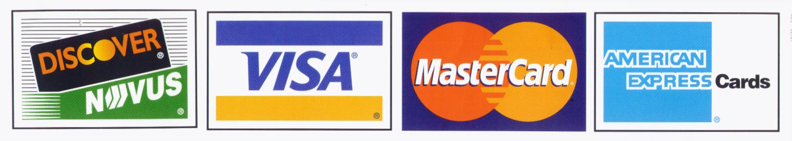
CREDIT/DEBIT CARD # EXP CVV
NAME
SHIPPING/BILLING ADDRESS
CITY STATE ZIP
PHONE ( ) EMAIL

Please make checks payable to: BLACK DOG ENTERPRISES
Note: A $25 returned check service charge is assessed for each dishonored check the bank returns.
All orders will be completed and mailed to your address within 2 months of the end of Tournament.
Shipping is FREE, except for Group (5+) or International orders: PLEASE ADD $20.00 SHIPPING.

