GAME DVD ORDER FORM
ICE HOCKEY – 2013 CAHA A/B STATE CHAMPIONSHIPS (APR 12-14, 2013)
TEAM: enter your team's name DIVISION: enter your team's division
DESCRIPTION
Individual Copies or Box Sets of Un-Edited Game DVDs with Live Commentary & Scoreboard Graphics

GROUP DISCOUNTS
We provide group discounts for multiple orders from the same team placed at the same time.
SPECIAL PRE-ORDER OFFER (placed before 5PM on 4/11/13): 5+ GOLD Packages = $45.00 EACH (30% OFF)
ON-SITE/POST-EVENT: 3 Packages = 10% discount, 5 Packages = 15% discount, 7+ packages = 20% discount

PACKAGES
COPPER: 1 GAME DVD $ 30.00
BRONZE: 2 GAME DVDs $ 45.00
SILVER: 3 GAME DVDs $ 55.00
GOLD: 4 GAME DVDs $ 65.00

ADDITIONAL GAME DVDs (5+) - $10.00 EACH (# 0 ): $ 0.00
ADDITIONAL PACKAGES (# 0 ): $ 0.00
SHIPPING (please add $20.00 for Group [5+] or International Orders): $ 0.00
DISCOUNT: 0%
TOTAL: $ 0.00
SELECTED GAMES
Please email us at INFO@BLACKDOGENTERPRISES.ORG with the list of games you wish to purchase.
Once the schedule has been released, please reference the schedule on our website for BDE Game #’s

GAME 1: GM # , GAME 2: GM # , GAME 3: GM # , GAME 4: GM #
ADDITIONAL GAMES: GM #

PAYMENT/SHIPPING INFO
CASH ($ ) CHECK (# ) CREDIT or DEBIT CARD 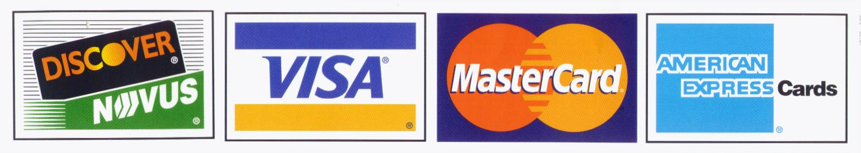
CREDIT/DEBIT CARD # EXP
NAME
SHIPPING/BILLING ADDRESS
CITY STATE ZIP
PHONE ( ) EMAIL

Please make checks payable to: BLACK DOG ENTERPRISES
Note: A $25 returned check service charge is assessed for each dishonored check the bank returns.
We will endeavor to complete as many orders as possible for on-site pick-up during the event.
All other orders will be completed and mailed to your address within 3 weeks of the end of Tournament.
Shipping is FREE, except for Group (5+) or International orders: PLEASE ADD $20.00 SHIPPING.

