LIVE SPORTS COVERAGE
Single camera video coverage of one (1) game. Coverage includes live 2-man audio commentary & dynamic integrated scoreboard overlays. Also includes ten (10) DVD copies & digital file download.

BRONZE: Single Camera w/2-man commentary $ 250.00
SILVER: Single Camera w/2-man commentary & Pay-Per-View live streaming $ 300.00
GOLD: Single Camera w/2-man commentary & Free live streaming $ 375.00
MULTI-GAME DISCOUNTS: 3 Games = 10% discount, 5 Games = 20% discount, 10+ packages = 30% discount

HIGHLIGHT REELS
Dynamic Edited Reels that showcase an individual player’s or an entire team’s best moments from selected games. Includes game footage with live audio commentary, music, graphics, and a player/team profile. Also includes one (1) personalized DVD & posting of footage on our website & YouTube channel.

CAMEO: HIGHLIGHT REEL w/CLIPS FROM 1-2 GAMES $ 250.00
PLAYMAKER: HIGHLIGHT REEL w/CLIPS FROM 3 GAMES $ 350.00
GOAL-SCORER: HIGHLIGHT REEL w/CLIPS FROM 4 GAMES $ 400.00
MULTI-REEL DISCOUNT: 10% off per additional reel ordered up to 30% off for all reels.

RECRUITING DVDS
Dynamic Edited Reels that showcase a player’s talents for junior/college recruiters. Reels feature HD game footage (single, isolated-camera), an interview with the player & their coach, a player profile, music, and graphics. Also includes one (1) personalized DVD & posting of footage on our website & YouTube channel.
ROCKET RICHARD: CLIPS FROM 2 GAMES & PLAYER/COACH INTERVIEW $ 350.00
BOBBY ORR: CLIPS FROM 3 GAMES & PLAYER/COACH INTERVIEW $ 500.00
MARIO LEMIEUX: CLIPS FROM 4 GAMES & PLAYER/COACH INTERVIEW $ 625.00
WAYNE GRETZKY: CLIPS FROM 5 GAMES & PLAYER/COACH INTERVIEW $ 750.00
MULTI-REEL DISCOUNT: 10% off per additional reel ordered up to 30% off for all reels.

SKILLS ASSESSMENTS
A multitude of services that can assist coaches in evaluating their team or provide players with specialized footage for junior/college recruiters. Each reel features HD game footage (single, isolated-camera). Includes digital file transfer & posting of footage on our website & YouTube channel.

COACHES’ FILM: Single Camera (unedited) $ 100.00
COACHES’ FILM: Single Camera (edited – coach’s selections) $ 150.00
RAW FOOTAGE REEL: Single Camera (edited – 1 player, all shifts/chances) $ 150.00
ON-ICE PRACTICE SHOOT: Multi-Camera (edited – drills of client’s choice) $ 250.00
MULTI-GAME DISCOUNTS: 3 Games = 10% discount, 5 Games = 15% discount, 10+ packages = 20% discount

NOTES
- Additional Footage to Edit – Highlight Reels: $50.00 per game, Recruiting DVDs: $75.00 per game
- Up to 25% discount if game, practice or interview footage is provided by the client.

ORDER SUMMARY
SUBTOTAL: $ 0.00
ADDITIONAL GAMES (# 0 ): $ 0.00 + ADDITIONAL REELS (# 0 ): $ 0.00 + ADDITIONAL FEES: $ 0.00
PROMO CODE (if applicable): / DISCOUNT: $ 0.00
TOTAL: $ 0.00
Please see additional fees list and complete shipping/billing info on Page 2

ADDITIONAL FEES
- Order completion time varies depending on type of service. Please inquire at time of purchase.
- Additional Fees may apply for Group or International orders. Please inquire at time of purchase.
- We are based in San Jose, CA. Additional fees may apply for services that require travel out of the area.

PAYMENT/SHIPPING INFO
CASH ($ ) CHECK (# ) CREDIT or DEBIT CARD 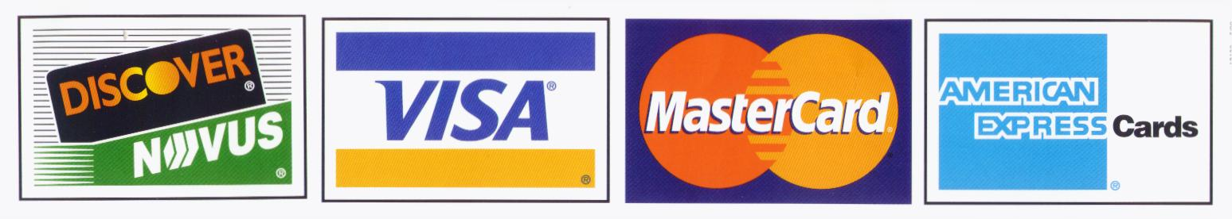
CREDIT/DEBIT CARD # EXP CVV
NAME
SHIPPING/BILLING ADDRESS
CITY STATE ZIP
PHONE ( ) EMAIL

Please make checks payable to: BLACK DOG ENTERPRISES
Note: A $25 returned check service charge is assessed for each dishonored check the bank returns.

