Bay Area Hockey Talk is a hockey recap/talk show featuring the latest news from the Northern California hockey scene. Our focus is on youth, high school & college hockey with secondary coverage of pro, minor pro and junior hockey. The show features game recaps, scoring summaries, panel discussions, interviews & pre-produced pieces. The show will be aired in two forms: weekly audio podcast & monthly video webcast.

This show will be listened to and/or viewed by potentially thousands of Bay Area hockey players, parents and administrators and provides a fantastic advertising opportunity for local businesses.

ADVERTISING OPPORTUNITIES (price listed per episode)
ON-AIR PROMO (100 WORDS): Ad read by on-air talent once per show $ _25.00
COMMERCIAL (30 SECONDS): Audio/Video spot played once per show $ _25.00
COMMERCIAL (60 SECONDS): Audio/Video spot played once per show $ _50.00
BOTTOM LINE TICKER: Lower 3rd graphic displayed alongside stats/scores for entire show $ _25.00
EPISODE SPONSOR: “Presenting” sponsor of an entire show $ _25.00
MULTI-SHOW DISCOUNTS: 2 Shows = 10% discount, 4 Shows = 20% discount, 8+ Shows = 30% discount

NOTES
- All graphics and video spots must be supplied by advertiser. If desired, we are capable of producing commercials for the advertiser for an additional fee.
- Please supply all finished artwork and video files at least one (1) week in advance of show date.
- File Formats – Audio: .MP3, .WAV; Graphics: .JPG, .GIF, or .PNG; Video: .MOV or .MP4

ORDER SUMMARY
SUBTOTAL: $ 0.00 x ADDITIONAL SHOWS (# 0 )
PROMO CODE (if applicable): / DISCOUNT: $ 0.00
TOTAL: $ 0.00

PAYMENT/SHIPPING INFO
CASH ($ ) CHECK (# ) CREDIT or DEBIT CARD 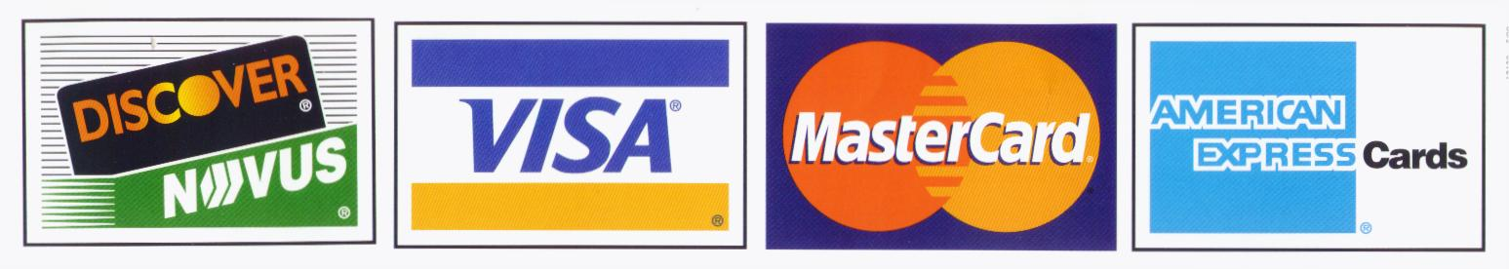
CREDIT/DEBIT CARD # EXP CVV
NAME
SHIPPING/BILLING ADDRESS
CITY STATE ZIP
PHONE ( ) EMAIL

Please make checks payable to: BLACK DOG ENTERPRISES
Note: A $25 returned check service charge is assessed for each dishonored check the bank returns.

