WEDDING VIDEOGRAPHY ORDER FORM
COUPLE: enter your names as you'd like them to appear in the finished product
CEREMONY DATE/TIME: 1/1/14 12:00 AM RECEPTION DATE/TIME: 1/1/14 12:00 AM
LOCATION(S): enter location(s) of the ceremony and reception

PACKAGE #1 - $1,499.00
1 Videographer for Pre-Ceremony, Ceremony & Reception
7 Continuous Hours of Coverage, Footage recorded in High Definition (720p/1080i)
1 Documentary DVD (60-90 minutes)
Features: venue footage, pre-ceremony bride/groom “getting ready,” full ceremony, all speeches, first dances
1 Highlight DVD (3-10 minutes) set to music of your choice, posted on our website and Vimeo
Features: best moments of your “Big Day” in a compact, upbeat highlight reel
1 External Hard Drive with All Raw HD Video Footage

PACKAGE #2 - $2,199.00
2 Videographers for Pre-Ceremony & Ceremony, 1 Videographer for Reception
8 Continuous Hours of Coverage, Footage recorded in High Definition (720p/1080i)
1 Documentary DVD Box Set (90-120 minutes)
Features: Package #1 features + Interviews w/Bridal Party & Parents, cake-cutting, garter toss, bouquet toss
1 Highlight DVD (3-10 minutes) set to music of your choice, posted on our website and Vimeo
Features: best moments of your “Big Day” in a compact, upbeat highlight reel
1 External Hard Drive with All Raw HD Video Footage

PACKAGE #3 - $2,999.00
3 Videographers for Ceremony, 2 Videographers for Pre-Ceremony & Reception
10 Continuous Hours of Coverage, Footage recorded in High Definition (720p/1080i)
1 Documentary DVD Box Set (2 DVDs, 120-180 minutes total)
Features: Package #2 features + more interviews, reception dancing, bride/groom “farewell”
1 Highlight DVD (3-10 minutes) set to music of your choice, posted on our website and Vimeo
Features: best moments of your “Big Day” in a compact, upbeat highlight reel
1 External Hard Drive with All Raw HD Video Footage

À LA CARTE OPTIONS/UPGRADES
Additional Cameras: $300.00 each (includes 2 hours of coverage w/operator) x 0 of cameras = $0.00
Additional Hours of Coverage: $100.00 per hour x 0 of cameras x 0 hours= $0.00
Additional DVD copies (any type): $20.00 each x 0 of copies = $0.00
Rehearsal Dinner Coverage: $100.00 per hour x 0 of cameras = $0.00
“Love Story” DVD (shot 4+ months before ceremony): $500.00 (4 hours included) = $0.00

ADDITIONAL NOTES/FEES
NOTE 1: We are based in San Jose, CA. All jobs over 100 miles round-trip require an additional $50.00 per 300 miles per order. Additional travel expenses may apply if overnight stay(s) and/or air/train transport are required.
NOTE 2: Cash or Check is the preferred payment method. For Cash/Check payments, a 3% discount will be applied to total.

PACKAGE #: $0.00 + À LA CARTE: $0.00 + ADDT’L FEES: $0.00 + DISCOUNTS $0.00 = TOTAL $0.00

50% Deposit ($0.00) Required to Reserve Date
Balance ($0.00) Due 2 weeks before Ceremony Date
PAYMENT/SHIPPING INFO
CASH ($ ) CHECK (# ) CREDIT or DEBIT CARD 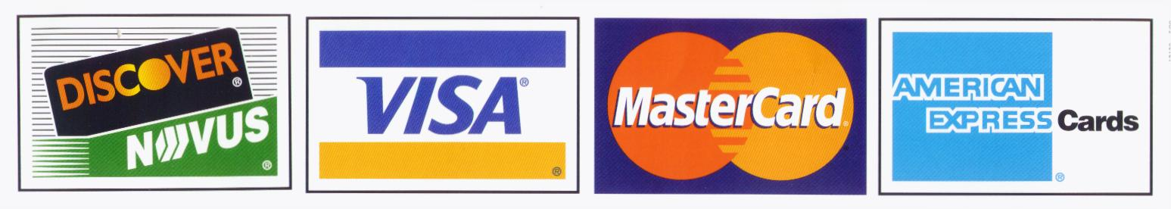
CREDIT/DEBIT CARD # EXP
NAME
SHIPPING/BILLING ADDRESS
CITY STATE ZIP
PHONE ( ) EMAIL

Please make checks payable to: BLACK DOG ENTERPRISES
Note: A $25 returned check service charge is assessed for each dishonored check the bank returns.
Finished Products will be produced & mailed to your address within 4 months after your wedding date (shipping is FREE).

