GAME DVD ORDER FORM
ICE HOCKEY – SHSHL VARSITY CHAMPIONSHIP GAME (MAY 31, 2015)
TEAM: enter your team's name DIVISION: enter your team's division
DESCRIPTION
Individual Copies or Box Sets of Un-Edited Game DVDs with Live Commentary & Scoreboard Graphics

DISCOUNTS
Experimental production using new equipment; DVDs available for 2/3 off regular rate due to errors that include the loss of portions of audio commentary, some video frame rate slowdown and portions of rough video source switching.

PACKAGES
COPPER: 1 GAME DVD $ 10.00

ADDITIONAL GAME DVDs (5+) - $10.00 EACH (# 0 ): $ 0.00
SHIPPING*: $ 0.00
DISCOUNT: 0%
TOTAL: $ 0.00

PAYMENT/SHIPPING INFO
CASH ($ ) CHECK (# ) CREDIT or DEBIT CARD 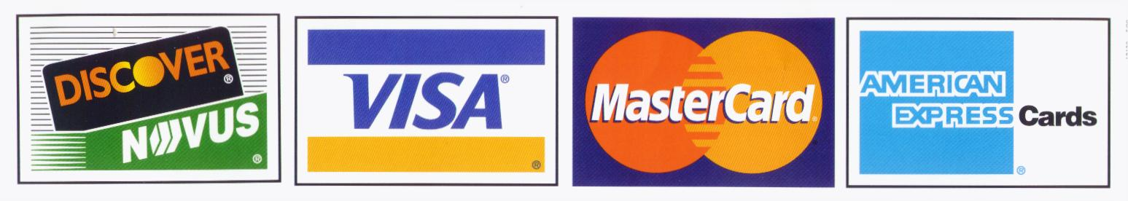
CREDIT/DEBIT CARD # EXP CVV
NAME
SHIPPING/BILLING ADDRESS
CITY STATE ZIP
PHONE ( ) EMAIL

Please make checks payable to: BLACK DOG ENTERPRISES
Note: A $25 returned check service charge is assessed for each dishonored check the bank returns.
All orders will be completed and mailed to your address within 3 weeks of the end of Tournament.
*Individual orders: shipping is FREE; Group (3+) or International orders: additional shipping fees may apply.

