GAME DVD ORDER FORM
ICE HOCKEY – 2014-15 ANAHEIM DUCKS HIGH SCHOOL HOCKEY LEAGUE
TEAM: enter your team's name DIVISION: enter your team's division
DESCRIPTION
Individual Copies or Box Sets of Un-Edited Game DVDs with Live Commentary & Scoreboard Graphics

PACKAGES
COPPER: 1 GAME DVD $ 30.00
BRONZE: 2 GAME DVDs $ 50.00
SILVER: 3 GAME DVDs $ 65.00
GOLD: 4 GAME DVDs $ 75.00

ADDITIONAL GAME DVDs (5+) - $10.00 EACH (# 0 ): $ 0.00
ADDITIONAL PACKAGES (# 0 ): $ 0.00
SHIPPING*: $ 0.00
DISCOUNT: 0%
TOTAL: $ 0.00
SELECTED GAMES
Please email us at INFO@BLACKDOGENTERPRISES.ORG with the list of games you wish to purchase.
Once the schedule has been released, please reference the schedule on our website for BDE Game #’s

GAME 1: GM # , GAME 2: GM # , GAME 3: GM # , GAME 4: GM #
ADDITIONAL GAMES: GM #

PAYMENT/SHIPPING INFO
CASH ($ ) CHECK (# ) CREDIT or DEBIT CARD 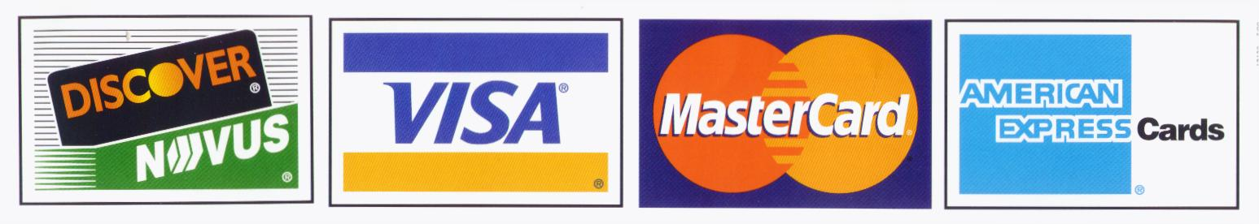
CREDIT/DEBIT CARD # EXP CVV
NAME
SHIPPING/BILLING ADDRESS
CITY STATE ZIP
PHONE ( ) EMAIL

Please make checks payable to: BLACK DOG ENTERPRISES
Note: A $25 returned check service charge is assessed for each dishonored check the bank returns.
All orders will be completed and mailed to your address within 2 weeks of purchase.
*Shipping is FREE, except for Group (3+) or International orders: PLEASE ADD $5.00 SHIPPING PER PACKAGE.

